AA tree
Contents:
- What is an AA tree?
- Some operation on AA tree:
- Skew and Split
- Inserting
- Deleting

I. Introduction:
AA tree is a balanced binary search tree, and is a variation of the red-black tree (RB tree). The different is in AA tree, the red nodes can only be added as a right child. Instead of using the color like in RB tree, AA tree actually use the concept of levels for balancing. AA trees are named after their inventor, Arne Andersson. Example for an AA tree:
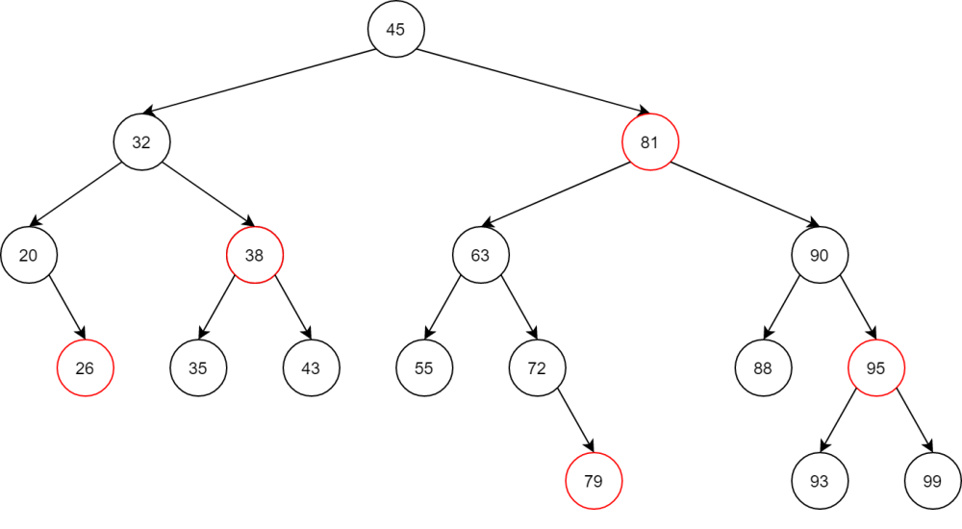
To learn how an AA tree work, we need to know some new definition first.
Level of a node :
- Is the number of left links from that node to a NULL node.
- Level of every NULL node is 0.
- Level of every leaf node is 1.
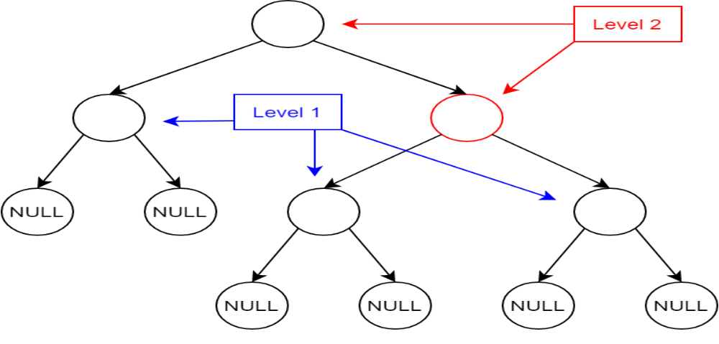
Horizontal link:
- Is a link between a parent node and its child whose levels are the same.
- Red nodes are at the same level as their parent, and the link between them is a horizontal link.
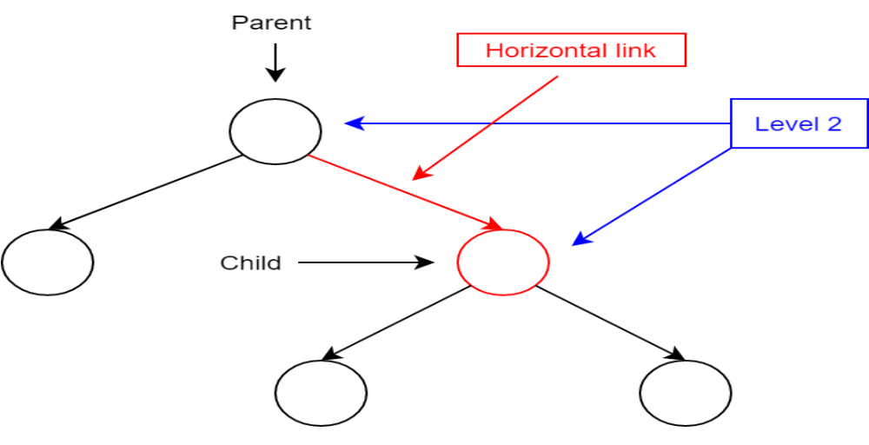
Re-draw the example AA tree with levels and horizontal links, the tree look like this:
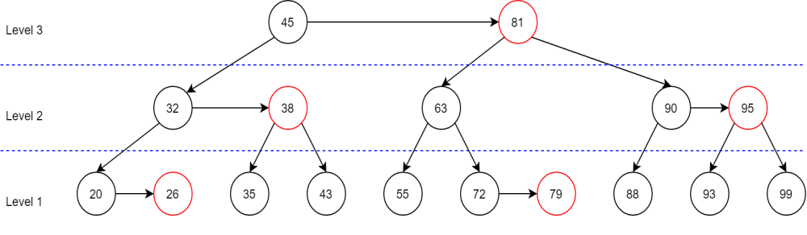
The AA tree follow the same rule as RB tree, with some new exclusive properties.
- Each node can be either red or black and root node is always black. In implementing, we don’t even need to use color for AA tree.
- Horizontal link is always oriented to the right. In other words, the red nodes, which connect to their parent by a horizontal link, are always the right child of their parent.
- There are no two adjacent red nodes (or horizontal links).
- Every node with level greater than 1 will have 2 children.
- If a node has no horizontal link, then its children are at the same level.
- Every path from a node (including root) to any of its descendant NULL node has the same number of black nodes. (or black links / normal links).

An AA tree need to satisfy five invariants :
- The level of leaf node is 1.
- The level of left child is exactly one less than of its parent.
- The level of every right child is equal to or one less than of its parent.
- The level of every right grandchild is strictly less than that of its grandparent.
- Every node of level greater than one has two children.

The implementation of the RB tree is very complex with so many cases that need to be considered to properly balance the tree. The AA tree simplifies it by removing many cases, make it easier to code.

RB tree needs to consider seven different shapes when balancing :
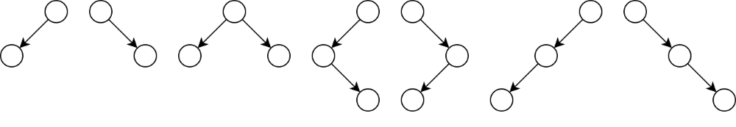
The AA tree reduce that number to two :

An AA tree node can be design similar to the RB tree node, without the need of parent node address and color status, and adding the level value.
struct node
{
int key;
node* left;
node* right;
int level;
};

II. Operations:
1. Traversing and searching:
Traversing and searching in AA tree is similar with a normal binary search tree.
For example : search for 79
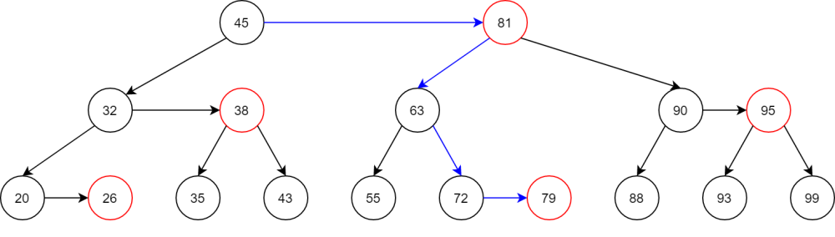
Search for 94 (not found)
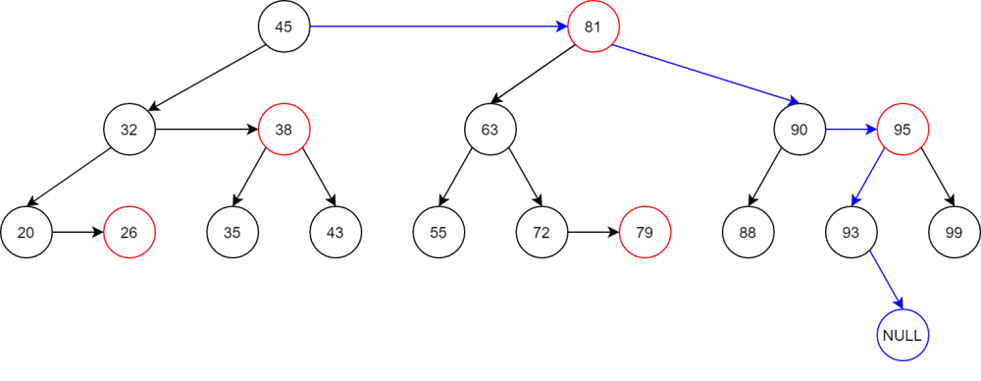
2. Skew and split:
Insertions and deletions may make the AA tree become unbalanced (by breaking the rules). Only two operations are needed to help rebanlacing after inserting or deleting, those are skew and split.

Skew is a single right rotation used when there is a left horizontal link, or in other words, there is a left red child. Skew can create consecutive right horizontal link in process.
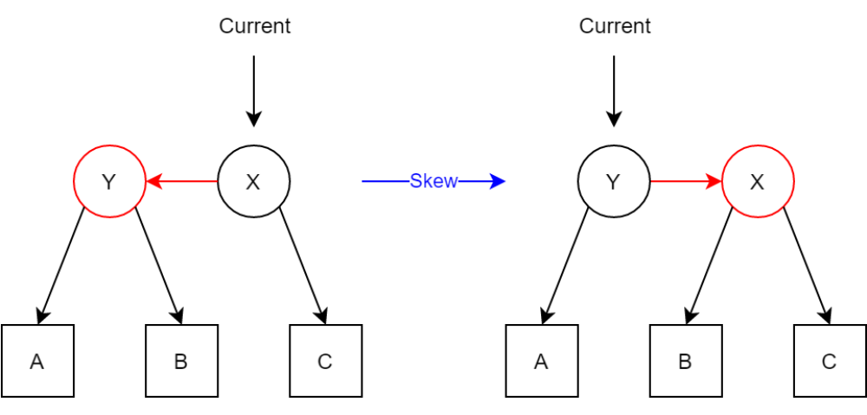
C++ code:
node* skew(node* curr)
{
if (curr == NULL) return curr; // NULL node break

if (curr->left != NULL) // the left child must exist
{
if (curr->left->level == curr->level) // the left child is at the same level as the parent
{
node* term = curr->left;
curr->left = term->right;
term->right = curr;

curr = term;
}
}
return curr;
}

Split is a single left rotation used when there are two consecutive right horizontal links, or in other words, two consective red node. Split also increase level of a node in process, in someway, the AA tree grow up similar to a B-tree.
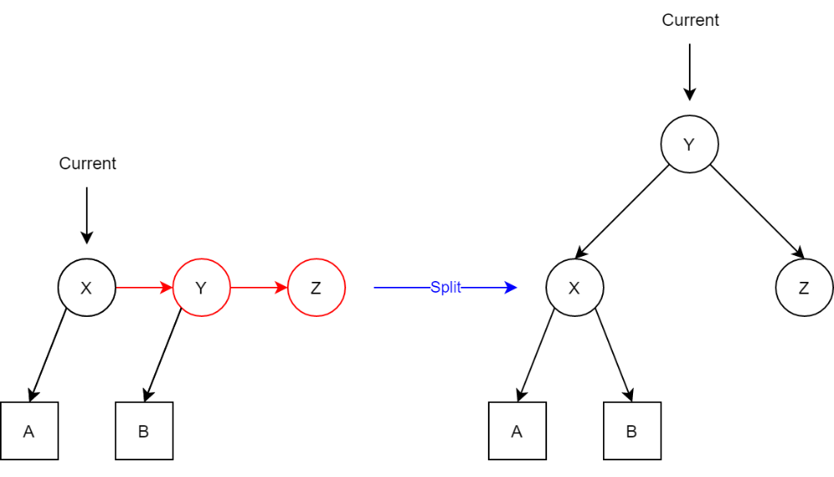
C++ code:
node* split(node* curr) // NULL node break
{
if (curr == NULL) return curr;

if (curr->right != NULL) // the right child must exist
{
if (curr->right->right != NULL) // the right grandchild must exist
{
// the right grandchild is at the same level as the grandparent
if (curr->right->right->level == curr->level)
{
node* term = curr->right;
curr->right = term->left;
term->left = curr;
term->level++;

curr = term;
}
}
}
return curr;
}

3. Inserting:
To add a new key to an AA tree, first execute like in a normal BST. The new node is always added at level 1.
- If it is added as a left child, it will create a left horizontal link : use skew operation to fix.
- If it is added as a right child, it will create a right horizontal link : if it cause two consecutive right horizontal link, use split operation to fix.
- Traverse back to root and fix if there is any violate.
Example : add 15 to this tree
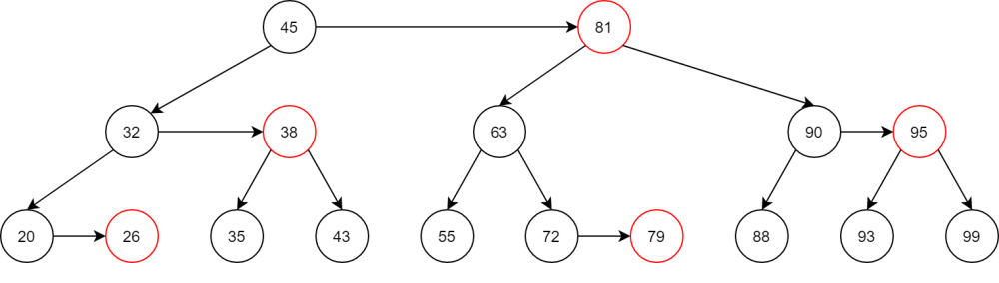
Traverse the tree to reach a NULL node, create a new node and add 15 to it. Level of this new node is 1.
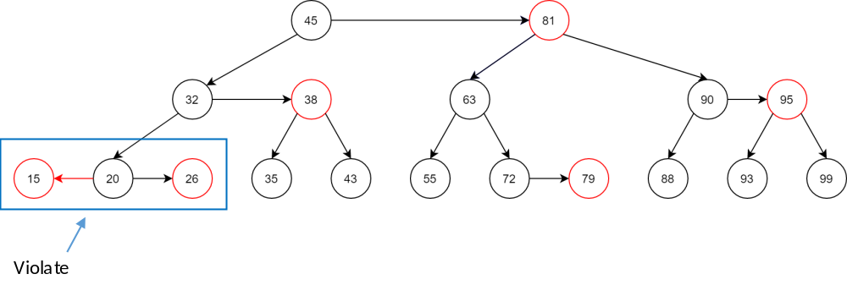
A left horizontal link is created, use skew at 20 to fix.
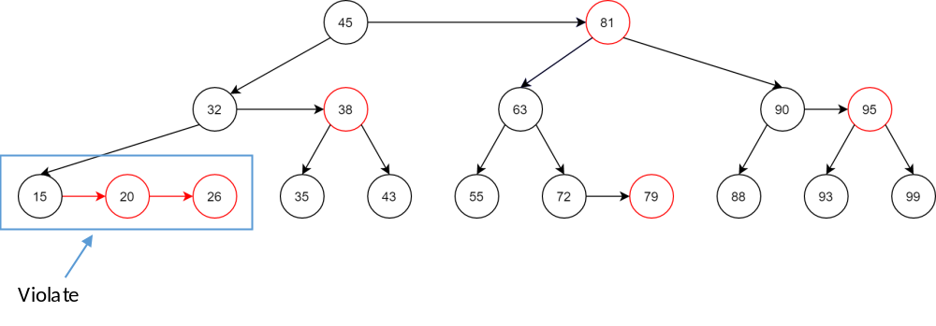
After skew at 20, two consecutive right horizontal links is created, use split at 15 to fix.
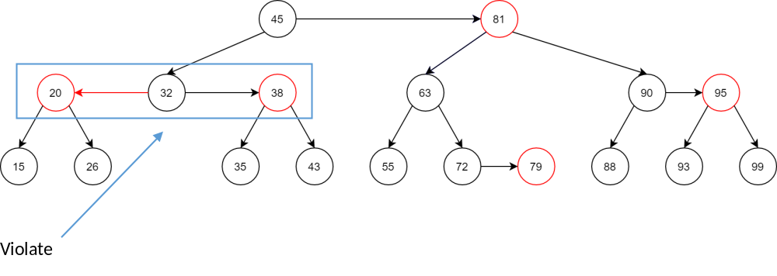
The split at 15 increase level of 20 to 2, putting it at the same level as its parent 32 and create a left horizontal link. Use skew at 32 to fix.
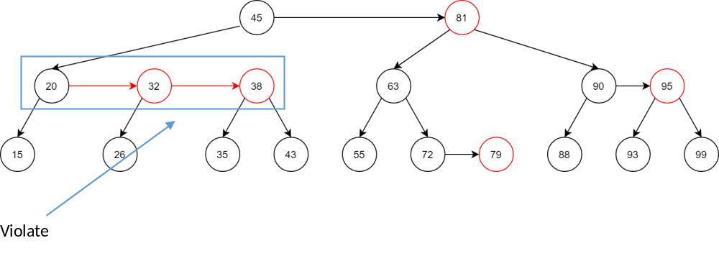
Again, the skew operation cause two consecutive right horizontal links. Use split at 20 to fix.
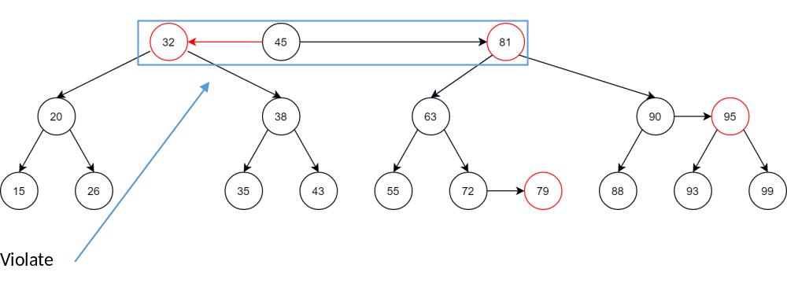
32 is put at level 3 and create a left horizontal link. Use skew at 45 to fix, 32 is now the new root.
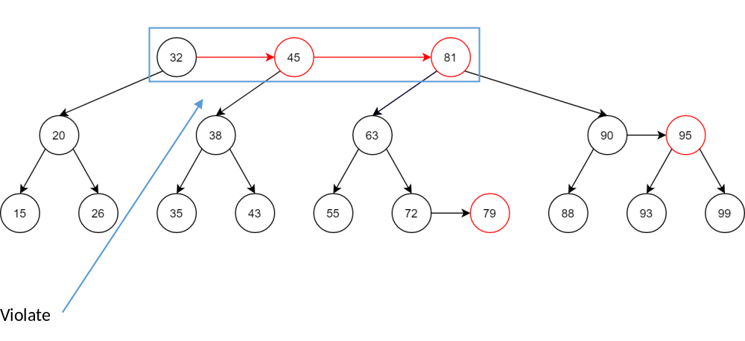
The skew cause two consecutive right horizontal links. Use split at 32 to fix.
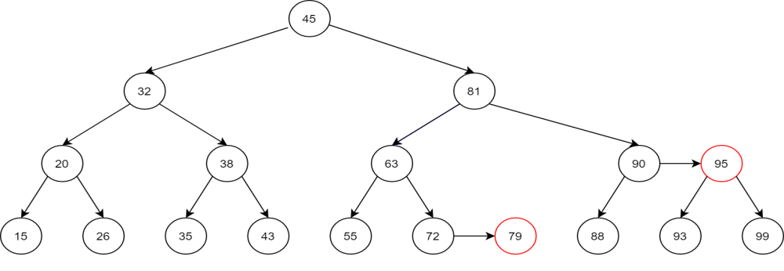
45 is now at level 4 and is the new root.
Adding 15 cause so many change to the tree, even create a new level. But now try again with adding 18, there is only 1 right horizontal link created, no adjustment needed.
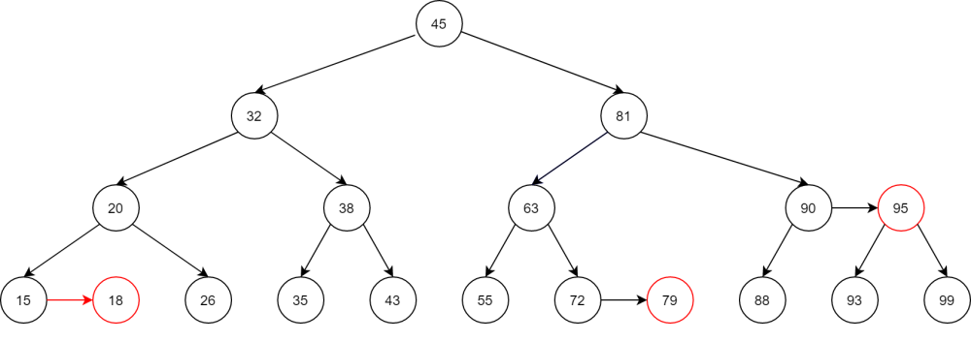
Implement in C++:
node* AAinsert(node* curr, int key)
{
if (curr == NULL)
{
curr = new node;
curr->key = key;
curr->left = NULL;
curr->right = NULL;
curr->level = 1;
}
else if (key < curr->key)
{
curr->left = AAinsert(curr->left, key);
}
else if (key > curr->key)
{
curr->right = AAinsert(curr->right, key);
}
else return curr;

curr = skew(curr);
curr = split(curr);

return curr;
}
4. Deletion:
To delete a key, first we also execute like in a normal BST. The actual deleted node is always a leaf node (always in level 1).
In the process, a node may lose one of its children, so we need to decrease its level. The ideal level of any node in the tree is one more than the minimum level of its children. If a node current level is higher than its ideal level, we need to decrease its to that ideal value. If the node has a right child that is a red node (at the same level and connected horizontally), then the level of the right child is also needs to be decreased.
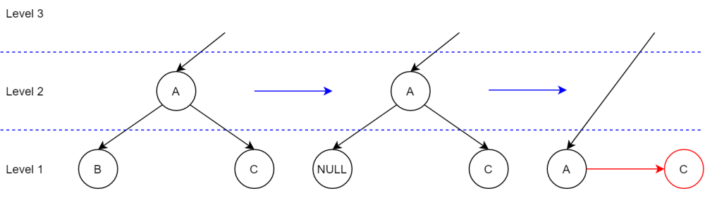
After updating the level of any node, the entire level need to be skewed and split.
- Perform skew at current node, its right child, and it right grandchild.
- Next, perform a split at current node, which turn it into its right child and turn its old grandchild into its new right child. Then, perform another split at the new right child.

Example : removing 63
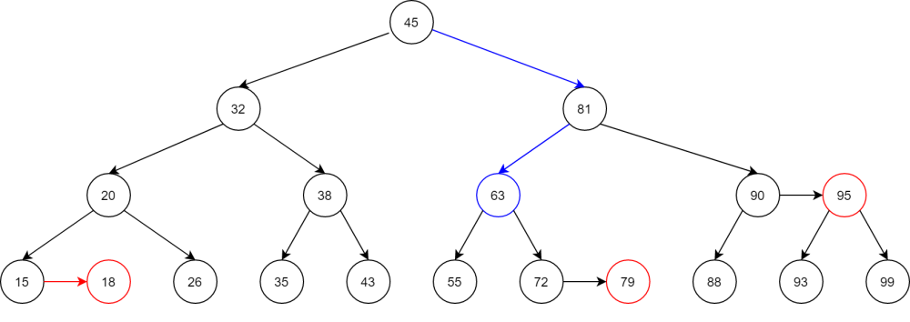
63 has two child, replace 63 with the largest value on its left sub tree, which is 55, and remove 55 from this left tree.
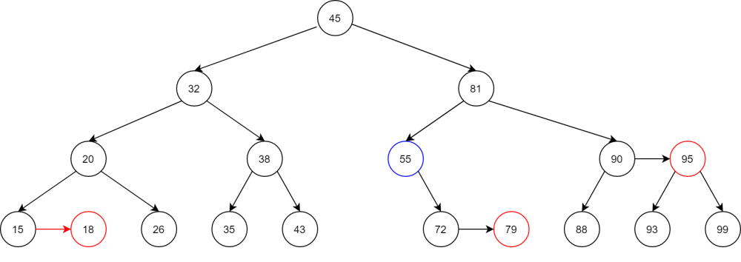
Now we check back up to the root node to see if there is any violation.
The ideal level of the node 55 is [1 + min(0,1)] = 1, but it is at level 2, decrease its level by 1. 55 don’t have right horizontal link, so we skip that part.
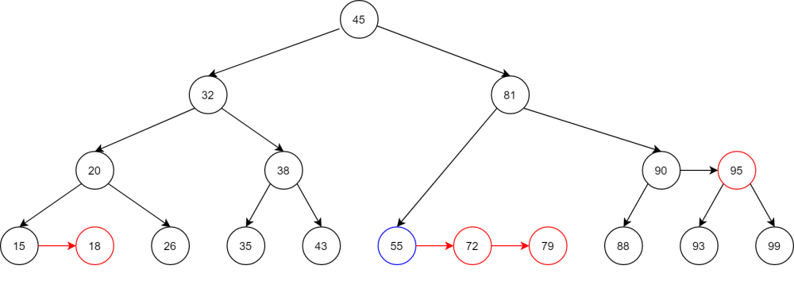
Perform skew at current node 55, its right child 72 and right grandchild 79. None of these node have left horizontal link, so nothing change.
Use split at current node 55.
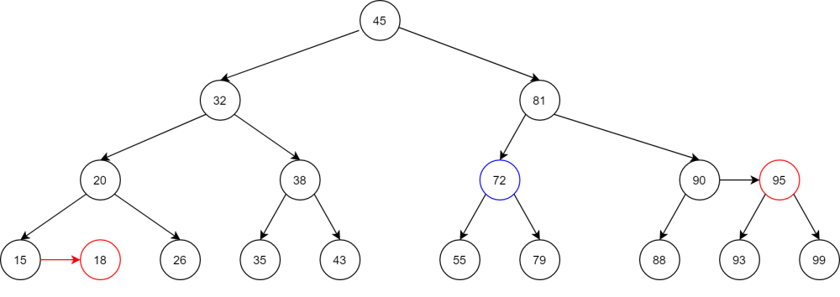
Then split at the right child 79. This node doens’t have right child so the split doesn’t happen.
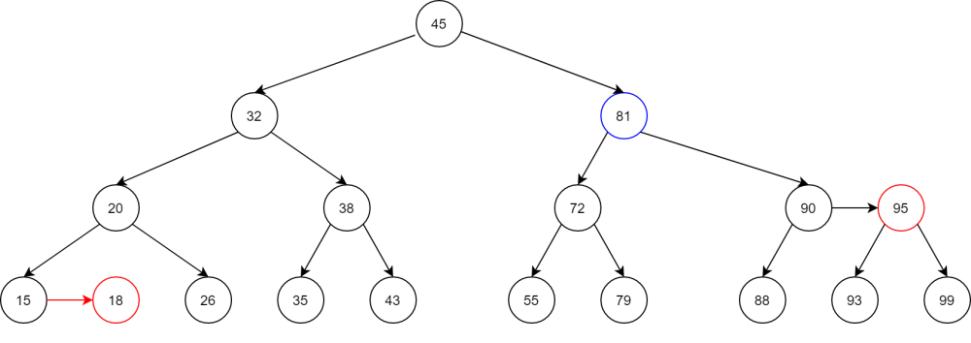
The ideal level of 81 is [1 + min(2,2)] = 3 is equal to its current level, no level updating is done. Skew at 81, 90 and 95, all are not happen. Split at 81 doesn’t happen because the level of its right grandchild 95 is different from its. Split at the right child 90 doesn’t happen because the level of its right grandchild 99 is different from its.
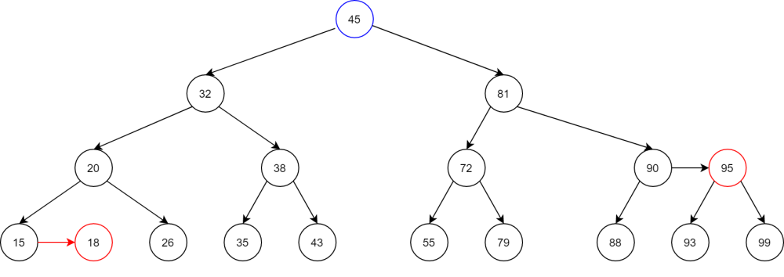
The ideal level of 81 is [1 + min(3,3)] = 4 is equal to its current level, no level updating is done. Skew at 45, 81 and 90, all are not happen. Split at 45 doesn’t happen because the level of its right grandchild 90 is different from its. Split at the right child 81 doesn’t happen because the level of its right grandchild 95 is different from its.
The root node is reached, stop balancing.

Now let’s remove 88.
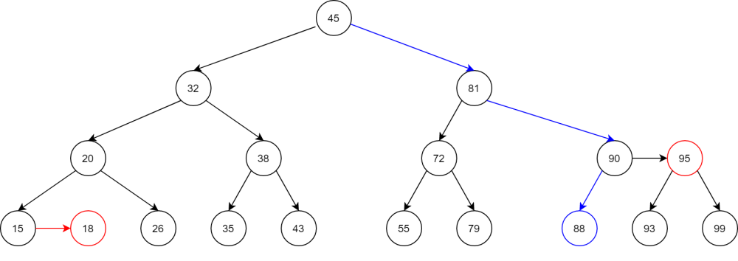
88 doesn’t have any child, just remove it.
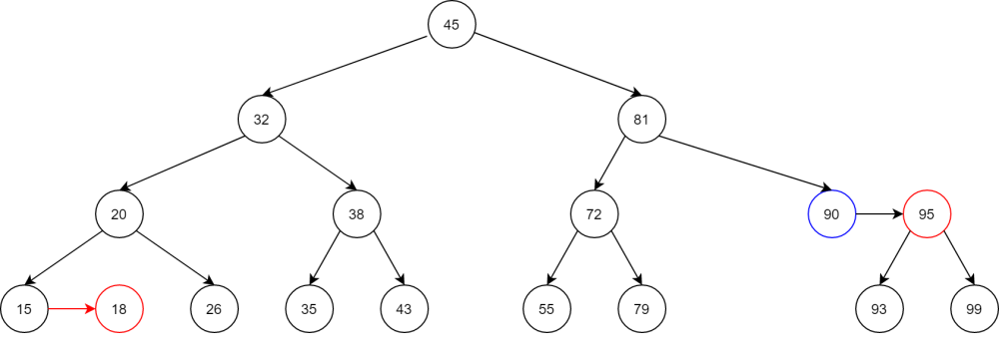
Begin rebalancing.
The ideal level of 90 is [1 + min(0,1)] = 1 is lower than its current level (2). Set 90 level to 1, and 90 has a horizontally connected right child 95, whose level will also be set to 1.
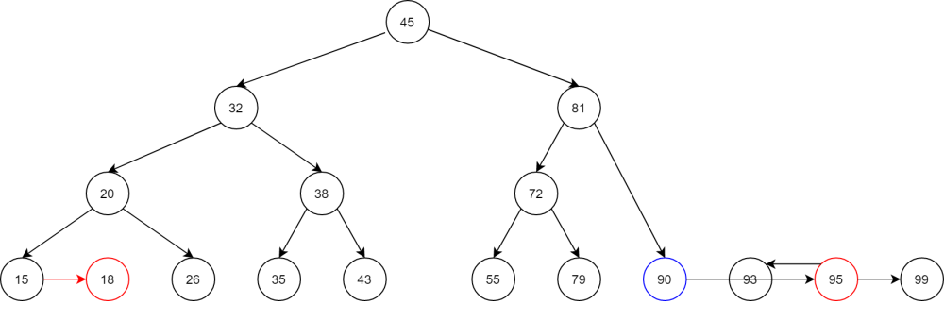
Perform skew at current node 90 doesn’t happen, at its right child 95 which happen and turn 95 into it new right grandchild. The skew at this new grandchild 95 doesn’t happen.
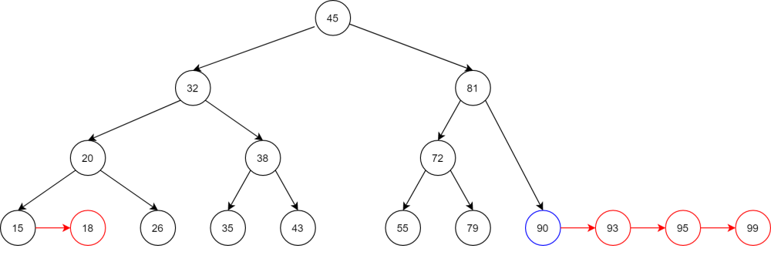
Perform split at 90.
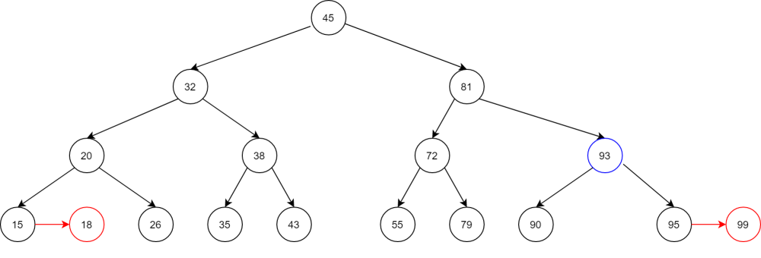
The split at 95 doesn’t happen because its right grandchild doesn’t exist.
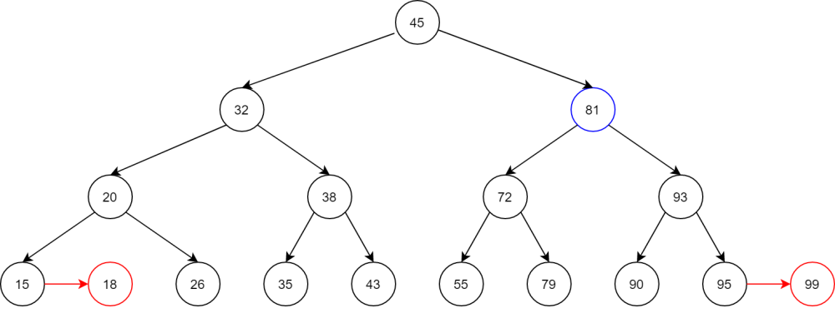
The ideal level of 81 is [1 + min(2,2)] = 3 is equal to its current level, no level updating is done. Skew at 81, 93 and 95, all are not happen. Split at 81 doesn’t happen because the level of its right grandchild 95 is different from its. Split at the right child 93 doesn’t happen because the level of its right grandchild 99 is different from its.

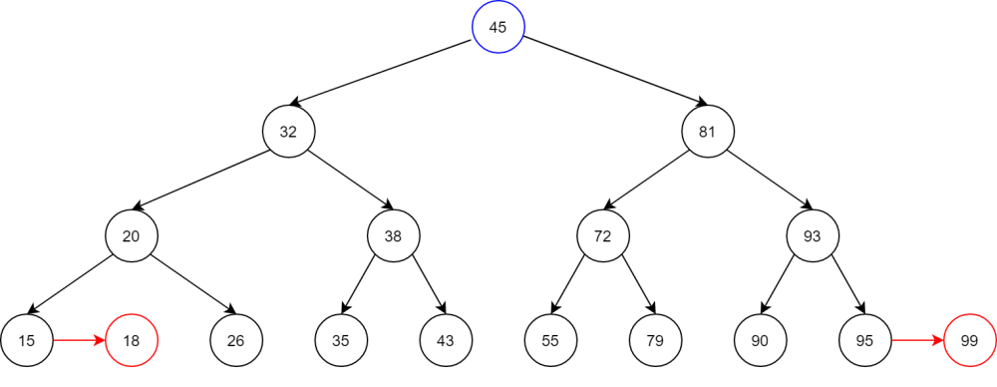
The ideal level of 45 is [1 + min(3,3)] = 4 is equal to its current level, no level updating is done. Skew at 45, 81 and 93, all are not happen. Split at 45 doesn’t happen because the level of its right grandchild 93 is different from its. Split at the right child 81 doesn’t happen because the level of its right grandchild 95 is different from its.
The root node is reached, stop balancing.

C++ code:
int minChildLevel(node* curr)
{
// return the minimum level of current node's children
int l, r;
if (curr->left == NULL) l = 0;
else l = curr->left->level;

if (curr->right == NULL) r = 0;
else r = curr->right->level;

return (l < r) ? l : r;
}

void updateLevel(node* curr)
{
int idealLevel = minChildLevel(curr) + 1;
if (curr->level > idealLevel) curr->level = idealLevel;
if ((curr->right != NULL)&&(curr->right->level > idealLevel)) curr->right->level = idealLevel;
}

void replaceLeft(node* curr,node* ori)
{
// replace current key with largest key in left sub tree
if (curr->right != NULL) return replaceLeft(curr->right, ori);

ori->key = curr->key;
}

void replaceRight(node* curr, node* ori)
{
// replace current key with smallest key in right sub tree
if (curr->left != NULL) return replaceRight(curr->left, ori);

ori->key = curr->key;
}

node* AArebalance(node* curr)
{
updateLevel(curr);

curr = skew(curr);
curr->right = skew(curr->right);
curr->right->right = skew(curr->right->right);

curr = split(curr);
curr->right = split(curr->right);

return curr;
}

node* AAdelete(node* curr, int key)
{
if (curr == NULL) return NULL;

if (key < curr->key) curr->left = AAdelete(curr->left, key);
else if (key > curr->key) curr->right = AAdelete(curr->right, key);
else
{
if (curr->left != NULL)
{
replaceLeft(curr->left, curr);
curr->left = AAdelete(curr->left, curr->key);
}
else if (curr->right != NULL)
{
replaceRight(curr->right, curr);
curr->right = AAdelete(curr->right, curr->key);
}
else
{
delete curr;
return NULL;
}
}

return AArebalance(curr);
}

